**Home Automation System**

**A PROJECT REPORT**

***Submitted by***

**Hitesh Aloney**

**Vipin Kumar Dinkar**

**Satya Prakash Tiwari**

***in partial fulfillment for the award of the degree***

***of***

**Bachelors in Computer Application**



**JAGANNATH INTERNATIONAL MANAGEMENT SCHOOL VASANT KUNJ, NEW DELHI**

April 2017

# **SELF CERTIFICATE**

This is to certify that the project report entitled “**Home Automation System**” is done by us is an authentic work carried out for the partial fulfillment of the requirements for the award of the degree of BCA under the guidance of **Mr. Deepak Sharma**. The matter embodied in this project work has not been submitted earlier for award of any degree or diploma to the best of my knowledge and belief.

Vipin Kumar Dinkar

**(00714202014)**

Hitesh Aloney

**(00314202014)**

Satya Prakash Tiwari

**(01314202014)**

# **CERTIFICATE**

This is to certify that the Project entitled **“Home Automation System”** is submited by the group of students “**Vipin Kumar Dinkar (00714202014), Hitesh Aloney (00314202014) and Satya Prakash Tiwari(01314202014)**” was partial fulfillment of the requirement of the **“Bachelor Of Computer Apllication”**  degree is a bona-fide record of the work done by them under my supervision during the project period as a project guide. The work carried out by them during the project is original and their performance during the compilation of project was appreciable.

Signature of the Guide

Date:

Name of the Guide: Mr. Deepak Sharma

Designation:

# **ACKNOWLEDGEMENT**

With candor and pleasure I take opportunity to express my sincere thanks and obligation to my esteemed guide **Mr. Deepak Sharma.** It is because of her able and mature guidance and cooperation without which it would not have been possible for me to complete my project.

It is my pleasant duty to thank all the staff member of the computer centre who never hesitated me from time to time during the project.

Finally, I gratefully acknowledge the support, encouragement and patience of my family, and as always, nothing in my life would be possible without God.

Thank You!

**Vipin Kumar Dinkar**

**(00714202014)**

**HItesh Aloney**

**(00314202014)**

**Satya Prakash Tiwari**

**(01314202014)**

**Contents**

**LIST OF FIGURES**

1. Circuit Diagram of Home Automation

**Chapter 1 - INTRODUCTION** **7**

1.1 Problem Statement 8

1.2 Objectives 8

1.3 Tools and Platform 9

1.3.1 Hardware Requirements 9

1.3.2 Software Requirements 14

1.4 Scope of this project 14

**Chapter 2 - SYSTEM ANALYSIS STUDY** **15**

2.2 System Requirements gathering 16

2.2.1. Questionnaire 16

2.2.2. Overview & Analysis of Data Gathered 18

2.3 Feasibility study 22

2.3.1 Technical Feasibility 24

2.3.2 Economical Feasibility 25

2.3.3 Operational Feasibility 25

**Chapter 3 - SYSTEM DESIGN** **26**

3.1 Introduction 27

3.2 System Design 28

3.2.1 System Diagram (Top View) 28

3.2.1 System Flow chart 29

3.2.2 System Schematics for Module I 30

3.3.3 System schematics for module II 31

3.3.4 Module I Diagram 32

3.3.5 Module II Diagram 33

**Chapter 4 - SYSTEM CODING AND IMPLEMENTATION** **34**

4.1 Introduction 35

4.1.1 System Coding Environment and Standards Followed 36

4.1.2 Sample Code Layouts 38

**Future scope of the project** **41**

Imagine what it would be like to have automatic lighting control, password locked door, automatic water motor off when the tank is full and be able to control everything from your [cell phone](https://www.adt.com/customer-service/mobile-security-apps). Consider for a moment having the ability and capability to properly manage energy to help lower your bill.[Wireless home security](https://www.adt.com/home-security) automation lets you do all this and more.

What is complete home automation? Basically, home automation can be defined as accessing or controlling many of your home’s appliances, security, climate, and video monitoring from a [remote](https://www.adt.com/remote-access) or centralized location.

In current scenario people are controlling their home manually. Since a person can’t be in two places at the same time, and hence he does not have the convenience to control his home remotely. There are many problems faced by people without home automation like they have to make sure that there house is closed properly, they can’t control the devices when away from home etc.

With this project we are going to solve problems like the users will be able to control the lighting automatically, they does not have to worry about the door lock, wastage of water can also be reduced by automatically switching of the motor when the tank is full, automatic lights on when the brightness is low. All these things will make the life of the users more convenient.

# 

# 

# **Chapter 1 - INTRODUCTION**

Imagine what it would be like to have automatic lighting control, password locked door,

automatic water motor off when the tank is full and be able to control everything from

your cell phone. Consider for a moment having the ability and capability to properly

manage energy to help lower your bill.Wireless home security automation lets you do all

this and more.

What is complete home automation? Basically, home automation can be defined as

accessing or controlling many of your home’s appliances, security, climate, and video

monitoring from a remote or centralized location.

In current scenario people are controlling their home manually. Since a person can’t be

in two places at the same time, and hence he does not have the convenience to control

his home remotely. There are many problems faced by people without home automation

like they have to make sure that there house is closed properly, they can’t control the

devices when away from home etc.

With this project we are going to solve problems like the users will be able to control the

lighting automatically, they does not have to worry about the door lock, wastage of

water can also be reduced by automatically switching of the motor when the tank is full,

automatic lights on when the brightness is low. All these things will make the life of the

users more convenient.

## **1.1 Problem Statement**

Parking facilities in residential areas has become a huge problem. There is lack of proper free spaces for parking due to increased unplanned housings in many places of the capital. There has been increase in the number of vehicles, but without sufficient parking spaces. Such growing number of small vehicles especially motorcycles and micro buses have created mess in the city including the increase in traffic jam. Another challenge due to the increased number of vehicles is undisciplined driving, which created obstacle for the traffic management system in Delhi. To improve all these, there is a need to create enough parking spaces.

## **1.2 Objectives**

1. To eliminate visitors from parking in local residential areas.
2. To eliminate unauthorized cars from parking in private areas.

## 

## 

## **1.3 Tools and Platform**

### **1.3.1 Hardware Requirements**

1. Arduino UNO R3
2. RFID MFRC522
3. Jumper Wires (male to male, female to female)
4. Servo Motor SG90
5. 3X4 keypad

**What is Arduino?**

Arduino is an open-source prototyping platform based on easy-to-use hardware and software. [Arduino boards](https://www.arduino.cc/en/Main/Products) are able to read inputs - light on a sensor, a finger on a button, or a Twitter message - and turn it into an output - activating a motor, turning on an LED, publishing something online. You can tell your board what to do by sending a set of instructions to the microcontroller on the board. To do so you use the Arduino programming language (based on Wiring), and [the Arduino Software (IDE)](https://www.arduino.cc/en/Main/Software), based on [Processing](https://processing.org/).

Over the years Arduino has been the brain of thousands of projects, from everyday objects to complex scientific instruments. A worldwide community of makers - students, hobbyists, artists, programmers, and professionals - has gathered around this open-source platform, their contributions have added up to an incredible amount of [accessible knowledge](http://forum.arduino.cc/) that can be of great help to novices and experts alike.

Arduino was born at the Ivrea Interaction Design Institute as an easy tool for fast prototyping, aimed at students without a background in electronics and programming. As soon as it reached a wider community, the Arduino board started changing to adapt to new needs and challenges, differentiating its offer from simple 8-bit boards to products for IoT applications, wearable, 3D printing, and embedded environments. All Arduino boards are completely open-source, empowering users to build them independently and eventually adapt them to their particular needs. The [software](https://www.arduino.cc/en/Main/Software), too, is open-source, and it is growing through the contributions of users worldwide.

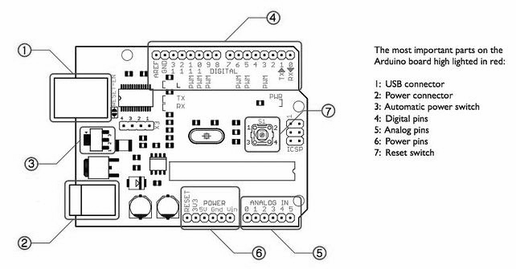

**Technical specs**

|  |  |
| --- | --- |
| Microcontroller | ATmega328P |
| Operating Voltage | 5V |
| Input Voltage (recommended) | 7-12V |
| Input Voltage (limit) | 6-20V |
| Digital I/O Pins | 14 (of which 6 provide PWM output) |
| PWM Digital I/O Pins | 6 |
| Analog Input Pins | 6 |
| DC Current per I/O Pin | 20 mA |
| DC Current for 3.3V Pin | 50 mA |
| Flash Memory | 32 KB (ATmega328P) of which 0.5 KB used by bootloader |
| SRAM | 2 KB (ATmega328P) |
| EEPROM | 1 KB (ATmega328P) |
| Clock Speed | 16 MHz |
| Length | 68.6 mm |
| Width | 53.4 mm |
| Weight | 25 g |

**Why Arduino?**

Thanks to its simple and accessible user experience, Arduino has been used in thousands of different projects and applications. The Arduino software is easy-to-use for beginners, yet flexible enough for advanced users. It runs on Mac, Windows, and Linux. Teachers and students use it to build low cost scientific instruments, to prove chemistry and physics principles, or to get started with programming and robotics. Designers and architects build interactive prototypes, musicians and artists use it for installations and to experiment with new musical instruments. Makers, of course, use it to build many of the projects exhibited at the Maker Faire, for example. Arduino is a key tool to learn new things. Anyone - children, hobbyists, artists, programmers - can start tinkering just following the step by step instructions of a kit, or sharing ideas online with other members of the Arduino community.

* **Inexpensive** - Arduino boards are relatively inexpensive compared to other microcontroller platforms. The least expensive version of the Arduino module can be assembled by hand, and even the pre-assembled Arduino modules cost less than $50
* **Cross-platform** - The Arduino Software (IDE) runs on Windows, Macintosh OSX, and Linux operating systems. Most microcontroller systems are limited to Windows.
* **Simple, clear programming environment** - The Arduino Software (IDE) is easy-to-use for beginners, yet flexible enough for advanced users to take advantage of as well. For teachers, it's conveniently based on the Processing programming environment, so students learning to program in that environment will be familiar with how the Arduino IDE works.
* **Open source and extensible software** - The Arduino software is published as open source tools, available for extension by experienced programmers. The language can be expanded through C++ libraries, and people wanting to understand the technical details can make the leap from Arduino to the AVR C programming language on which it's based. Similarly, you can add AVR-C code directly into your Arduino programs if you want to.
* **Open source and extensible hardware** - The plans of the Arduino boards are published under a Creative Commons license, so experienced circuit designers can make their own version of the module, extending it and improving it. Even relatively inexperienced users can build the [breadboard version of the module](https://www.arduino.cc/en/Main/Standalone) in order to understand how it works and save money.

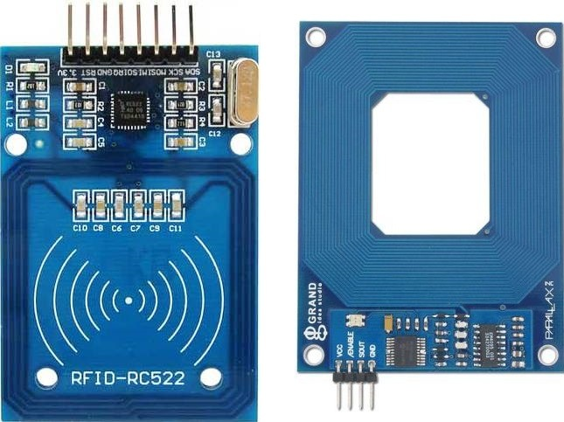

**RFID**

RFID tagging is an ID system that uses small radio frequency identification devices for identification and tracking purposes. An RFID tagging system includes the tag itself, a read/write device, and a host system application for data collection, processing, and transmission. In simple words an RFID uses electromagnetic fields to transfer data over

short distances. RFID is useful to identify people, to make transactions,etc…

You can use an RFID system to open a door. For example, only the person with the right information on his card is allowed to enter.

The MFRC522 is a highly integrated reader/writer IC for contactless communication at 13.56 MHz. The MFRC522 reader supports ISO/IEC 14443 A/MIFARE and NTAG.

An RFID system

**Uses:**

>> tags attached to the object to be identified, Each tag has his own identification

(UID).

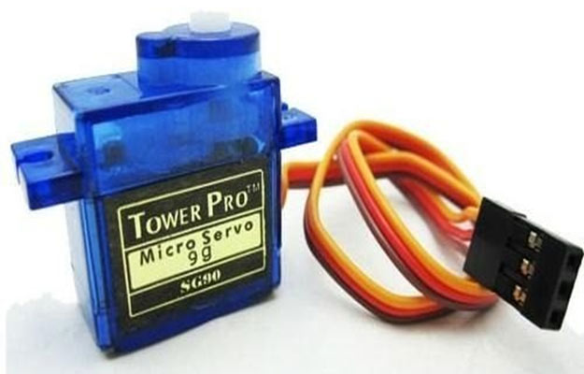

**Servo Motor**

Tiny and lightweight with high output power. Servo can rotate approximately 180 degrees (90 in each direction), and works just like the standard kinds but smaller. You can use any servo code, hardware or library to control these servos. Good for beginners who want to make stuff move without building a motor controller with feedback & gear box, especially since it will fit in small places. It comes with a 3 horns (arms) and hardware.

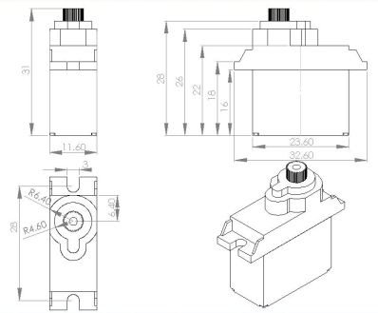

**Servo Motor SG90 Specifications**

Dimensions: 22 x 11.5 x 27mm

Operating Speed (4.8V no load): 0.12sec/60 degrees

Stall Torque : 1.2kg / 42.3oz(4.8V);1.6 kg / 56.4oz (6.0V)

Temperature Range: -30 to +60 Degree C

Dead Band Width: 7usec

Operating Voltage:3.0-7.2 Volts

**3X4 Keypad**

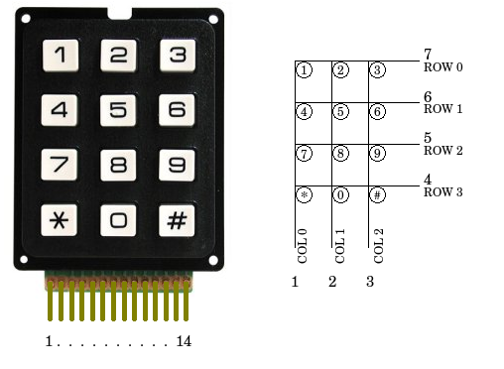

**General Specification**

* Contact rating:20mA,24VDC
* Contact resistance:200 ohm max
* Life:1,000,000 cycles per key
* Operating Temperature: -20C to +60C
* Storage Temperature: -40C to +65C

### 

### 

### 

### 

### **1.3.2 Software Requirements**

**ARDUINO 1.6.11**

The open-source Arduino Software (IDE) makes it easy to write code and upload it to the board. It runs on Windows, Mac OS X, and Linux. The environment is written in Java and based on Processing and other open-source software.

The Arduino project provides the Arduino [integrated development environment](https://en.wikipedia.org/wiki/Integrated_development_environment) (IDE), which is a [cross-platform](https://en.wikipedia.org/wiki/Cross-platform) application written in the programming language [Java](https://en.wikipedia.org/wiki/Java_(programming_language)). It originated from the IDE for the languages Processing and Wiring. It is designed to introduce programming to artists and other newcomers unfamiliar with software development. It includes a code editor with features such as [syntax highlighting](https://en.wikipedia.org/wiki/Syntax_highlighting), [brace matching](https://en.wikipedia.org/wiki/Brace_matching), and automatic indentation, and provides simple one-click mechanism to compile and load programs to an Arduino board. A program written with the IDE for Arduino is called a "sketch”.

The Arduino IDE supports the languages [C](https://en.wikipedia.org/wiki/C_(programming_language)) and [C++](https://en.wikipedia.org/wiki/C%2B%2B) using special rules to organize code. The Arduino IDE supplies a [software library](https://en.wikipedia.org/wiki/Software_library) called Wiring from the Wiring project, which provides many common input and output procedure.

## **1.4 Scope of this project**

**Scope**

* There is only one time investment

# 

# 

# 

# 

# 

# **Chapter 2 - SYSTEM ANALYSIS STUDY**

## 

## 

## 

## 

## **2.2 System Requirements gathering**

### **2.2.1. Questionnaire**

Questionnaires are frequently used in [quantitative marketing research](https://en.wikipedia.org/wiki/Quantitative_marketing_research) and [social research](https://en.wikipedia.org/wiki/Social_research). They are a valuable method of collecting a wide range of information from a large number of individuals, often referred to as respondents, it can be students, workers or any person whom you require information from.

Adequate questionnaire construction is critical to the success of a survey. Inappropriate questions, incorrect ordering of questions, incorrect scaling, or bad questionnaire format can make the survey valueless, as it may not accurately reflect the views and opinions of the participants.

Different methods can be useful for checking a questionnaire and making sure it is accurately capturing the intended information.

**Following questionnaire was used in this project to gather data from the user**

1. What is your name?

2. Do you own a vehicle? If yes, which one?

(a) Car

(b) Bike

(c) Both

(d) I don't own any vehicle

3. If yes, How many?

(a) 1

(b) 2

(c) More than 2

4. Where do you usually park your vehicle? *

(a) Near my home

(b) Somewhere inside the colony.

(c) Any free space.

5. Do you have any parking problems?

(a) Yes

(b) No

(c) Sometimes

6. Do you have visitors parking where you usually park?

(a) Yes

(b) No

(c) Sometimes

7. Did you have any security problems where you usually park?

(a) Yes

(b) No

(c) Sometimes

8. Do you want your own parking space?

(a) Yes

(b) No

9. We are developing a smart car parking system in your area where we provide security and space to your vehicles. Do you want to use this service?

(a) Yes

(b) No

10. If implemented, would you recommend our services to your friends in different neighborhood if you are satisfied?

(a) Yes

(b) No

### 

### 

### **2.2.2. Overview & Analysis of Data Gathered**

## 

## 

## 

## 

## 

## 

## 

## 

## 

## 

## 

## 

## 

## 

## 

## 

## 

## 

## **2.3 Feasibility study**

**Definitions**

**What is a 'Feasibility Study'?**

A feasibility study is an analysis of how successfully a project can be completed, accounting for factors that affect it such as economic, technological, legal and scheduling factors. Project managers use feasibility studies to determine potential positive and negative outcomes of a project before [investing](http://www.investopedia.com/terms/i/investing.asp) a considerable amount of time and money into it.

There are many different types of feasibility studies; here is a list of some of the most common:

* **Technical Feasibility** - Does the company have the technological resources to undertake the project? Are the processes and procedures conducive to project success?
* **Economic Feasibility** - Given the financial resources of the company, is the project something that can be completed? The economic feasibility study is more commonly called the cost/benefit analysis.
* **Operational Feasibility** - This measures how well your company will be able to solve problems and take advantage of opportunities that are presented during the course of the project

**Importance**

Feasibility studies allow companies to determine and organize all of the necessary details to make a business work. A feasibility study helps identify logistical problems, and nearly all business-related problems, along with the solutions to alleviate them. Feasibility studies can also lead to the development of marketing strategies that convince investors or a bank that investing in the business is a wise choice.

**Feasibility study: Home Automation**

**1. Description of problem**

Parking facilities in residential areas has become a huge problem. There is lack of proper free spaces for parking due to increased unplanned housings in many places of the capital. There has been increase in the number of vehicles, but without sufficient parking spaces. Such growing number of small vehicles especially motorcycles and micro buses have created mess in the city including the increase in traffic jam. Another challenge due to the increased number of vehicles is undisciplined driving, which created obstacle for the traffic management system in Delhi. To improve all these, there is a need to create enough parking spaces.

**2. Objectives**

1. To eliminate visitors from parking in local residential areas.
2. To eliminate unauthorized cars from parking in private areas.
3. Safe, convenient, and available parking and transport for all members of the campus community is an important college service that should be improved at each opportunity.
4. To create a system in which a driver can easily distinguish if there is an available space to park and to easily locate it even without entering the parking area.
5. Controlled number of vehicles in the parking area.

**Description of existing solution**

* Appointing guards for reserving parking space.
* Writing their car number on the wall.
* Putting sign boards which says ‘Reserved parking’ or ‘No parking’.
* Parking other vehicles (if they have) on their usual parking space to prevent outsiders from parking on that spot.

**Description of other possible solution**

**An automated parking control system (Proposed solution):**

* Using RFID sensor, we can restrict parking to authorized personnel only.
* Less downtime, hence preventing theft and other security issues.
* No need to appoint guards because it is handled by a microcontroller.

### **2.3.1 Technical Feasibility**

**Technical feasibility** is one of the first studies that must be conducted after a [project](https://en.wikipedia.org/wiki/Project) has been identified. In large engineering projects consulting agencies that have large staffs of engineers and technicians conduct technical studies dealing with the projects. In individual agricultural projects financed by local agricultural credit corporations, the technical staff composed of specialized agricultural engineers, irrigation and construction engineers, and other technicians are responsible for conducting such as feasibility studies.

In our project, we prepared technical feasibility on the following aspects:

* Materials
  + - Arduino UNO R3
    - RFID MFRC522
    - Jumper Wires (male to male, female to female)
    - Servo Motor SG90
    - 3X4 keypad
* Labor
* Transportation or Shipping
  + - All goods can be shipped using your local courier services like Bluedart etc. which is feasible. For this project, we bought these materials from Amazon.in and they were shipped using ATS(Amazon transportation services.)
* Physical Location
  + - This project doesn’t require a special place.
    - Arduino can be coded from home itself using any regular pc and the software used is free of cost.
    - Assembling can be done anywhere where this project will be implemented.
* Technology

### 

### **2.3.2 Economical Feasibility**

For any system if the expected benefits equal or exceed the expected costs, the system can be judged to be economically feasible. In economic feasibility, cost benefit analysis is done in which expected costs and benefits are evaluated. Economic analysis is used for evaluating the effectiveness of the proposed system.

In economic feasibility, the most important is cost-benefit analysis. As the name suggests, it is an analysis of the costs to be incurred in the system and benefits derivable out of the system. Click on the link below which will get you to the page that explains what cost benefit analysis is and how you can perform a cost benefit analysis.

### **2.3.3 Operational Feasibility**

Operational feasibility is a measure of how well a proposed system solves the problems, and takes advantage of the opportunities identified during scope definition and how it satisfies the requirements identified in the requirements analysis phase of system development.

The operational feasibility assessment focuses on the degree to which the proposed development projects fits in with the existing business environment and objectives with regard to development schedule, delivery date, corporate culture and existing business processes.

To ensure success, desired operational outcomes must be imparted during design and development. These include such design-dependent parameters such as reliability, maintainability, supportability, usability, producibility, disposability, sustainability, affordability and others. These parameters are required to be considered at the early stages of design if desired operational behaviours are to be realised. A system design and development requires appropriate and timely application of engineering and management efforts to meet the previously mentioned parameters. A system may serve its intended purpose most effectively when its technical and operating characteristics are engineered into the design. Therefore, operational feasibility is a critical aspect of systems engineering that needs to be an integral part of the early design phases.

# 

# 

# **Chapter 3 - SYSTEM DESIGN**

# 

# 

## 

## 

## 

## 

## 

## **3.1 Introduction**

Systems design is the process of defining the architecture, components, modules, interfaces, and [data](https://en.wikipedia.org/wiki/Data) for a [system](https://en.wikipedia.org/wiki/System) to satisfy specified [requirements](https://en.wikipedia.org/wiki/Requirement). Systems design could be seen as the application of [systems theory](https://en.wikipedia.org/wiki/Systems_theory) to [product development](https://en.wikipedia.org/wiki/Product_development). It is meant to satisfy specific needs and requirements of a business or organization through the engineering of a coherent and well-running system.

Systems design implies a systematic approach to the design of a system. It may take a bottom-up or top-down approach, but either way the process is systematic wherein it takes into account all related variables of the system that needs to be created—from the architecture, to the required hardware and software, right down to the data and how it travels and transforms throughout its travel through the system.

## **3.2 System Design**

### **3.2.1 System Schematics for Module I**

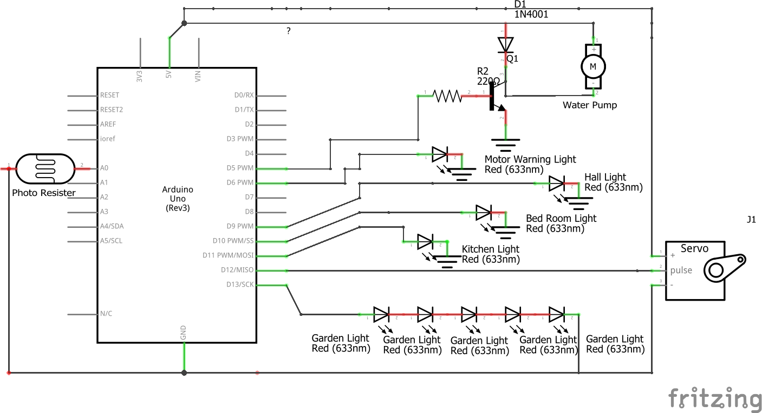

### **3.2.2 System Schematics for Module II**

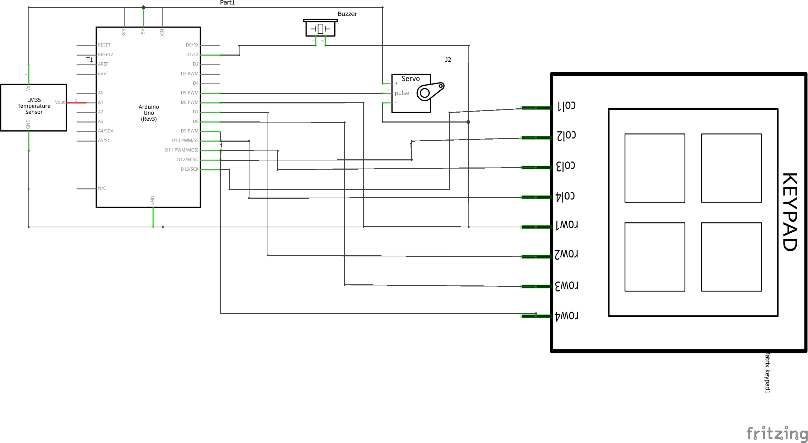

# 

# **Chapter 4 - SYSTEM CODING AND IMPLEMENTATION**

## **4.1 Introduction**

**What is Arduino?**

Arduino is an open-source electronics platform based on easy-to-use hardware and software. [Arduino boards](https://www.arduino.cc/en/Main/Products) are able to read inputs - light on a sensor, a finger on a button, or a Twitter message - and turn it into an output - activating a motor, turning on an LED, publishing something online. You can tell your board what to do by sending a set of instructions to the microcontroller on the board. To do so you use the [Arduino programming language](https://www.arduino.cc/en/Reference/HomePage) (based on [Wiring](http://wiring.org.co/)), and [the Arduino Software (IDE)](https://www.arduino.cc/en/Main/Software), based on [Processing](https://processing.org/).

Over the years Arduino has been the brain of thousands of projects, from everyday objects to complex scientific instruments. A worldwide community of makers - students, hobbyists, artists, programmers, and professionals - has gathered around this open-source platform, their contributions have added up to an incredible amount of [accessible knowledge](http://forum.arduino.cc/) that can be of great help to novices and experts alike.

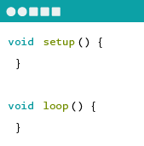

**ARDUINO SOFTWARE**

You can tell your Arduino what to do by writing code in the Arduino programming language and using the Arduino development environment.

### **4.1.1 System Coding Environment and Standards Followed**

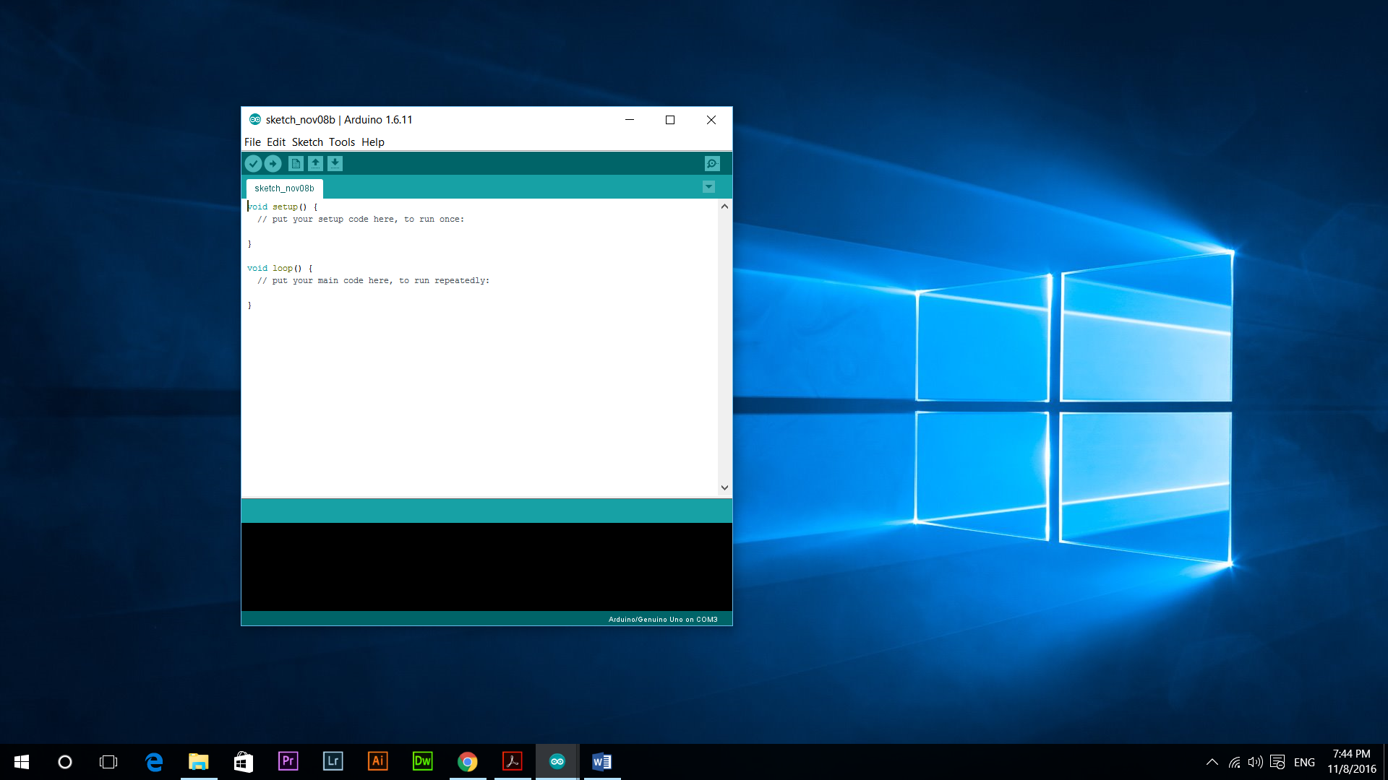

The Arduino Integrated Development Environment - or Arduino Software (IDE) - contains a text editor for writing code, a message area, a text console, a toolbar with buttons for common functions and a series of menus. It connects to the Arduino and Genuino hardware to upload programs and communicate with them.

**Writing Sketches**

Programs written using Arduino Software (IDE) are called sketches. These sketches are written in the text editor and are saved with the file extension .ino. The editor has features for cutting/pasting and for searching/replacing text. The message area gives feedback while saving and exporting and also displays errors. The console displays text output by the Arduino Software (IDE), including complete error messages and other information. The bottom righthand corner of the window displays the configured board and serial port. The toolbar buttons allow you to verify and upload programs, create, open, and save sketches, and open the serial monitor.

**Libraries**

Libraries provide extra functionality for use in sketches, e.g. working with hardware or manipulating data. To use a library in a sketch, select it from the Sketch > Import Library menu. This will insert one or more #include statements at the top of the sketch and compile the library with your sketch. Because libraries are uploaded to the board with your sketch, they increase the amount of space it takes up. If a sketch no longer needs a library, simply delete its #include statements from the top of your code.

Some of the libraries used in this system are:

**Servo library**

|  |
| --- |
| This library allows an Arduino board to control RC (hobby) servo motors. Servos have integrated gears and a shaft that can be precisely controlled. Standard servos allow the shaft to be positioned at various angles, usually between 0 and 180 degrees. Continuous rotation servos allow the rotation of the shaft to be set to various speeds. |

### 

### 

### 

### 

### 

### 

### **4.1.2 Sample Code Layouts**

**For Running Blynk Server**

@echo off

setlocal EnableDelayedExpansion

REM === Edit these lines to match your need ===

set COMM_PORT=com5

set COMM_BAUD=9600

set SERV_ADDR=blynk-cloud.com

set SERV_PORT=8442

REM === Edit lines below only if absolutely sure what you're doing ===

rem Get command line options

set SCRIPTS_PATH=%~dp0

:loop

IF NOT "%1"=="" (

IF "%1"=="-c" set COMM_PORT=%2& SHIFT & SHIFT & GOTO :loop

IF "%1"=="-b" set COMM_BAUD=%2& SHIFT & SHIFT & GOTO :loop

IF "%1"=="-s" set SERV_ADDR=%2& SHIFT & SHIFT & GOTO :loop

IF "%1"=="-p" set SERV_PORT=%2& SHIFT & SHIFT & GOTO :loop

CALL :usage

GOTO :eof

)

rem Find ports

set PORTS=

for /f "tokens=4 delims=: " %%A in ('mode^|findstr "COM[0-9]*:"') do IF not [%%A] == [] set PORTS=!PORTS! %%A

set PORTS=!PORTS:~1!

rem Check port

rem Skip check if no ports at all - Windows bug?

if not "x%PORTS%"=="x~1" (

if "x!PORTS:%COMM_PORT%=!"=="x%PORTS%" (

echo %COMM_PORT% not found, or may be busy.

set /p COMM_PORT="Select serial port [ %PORTS% ]: "

)

)

rem Create exe

if not exist "%SCRIPTS_PATH%\com2tcp.exe" (

copy "%SCRIPTS_PATH%\com2tcp.bin" "%SCRIPTS_PATH%\com2tcp.exe" > NUL

)

rem Do the job

echo Connecting device at %COMM_PORT% to %SERV_ADDR%:%SERV_PORT%...

rem Try resetting board

rem mode %COMM_PORT%:%COMM_BAUD%,N,8,1 >nul

:restart

"%SCRIPTS_PATH%\com2tcp.exe" --baud %COMM_BAUD% --ignore-dsr \\.\%COMM_PORT% %SERV_ADDR% %SERV_PORT%

echo Reconnecting in 3s...

timeout /T 3

goto restart

goto:eof

:usage

echo.

echo. This script redirects serial communication to the server.

echo.

echo. You can specify port, baud rate, and server endpoint like this:

echo. blynk-ser.bat -c ^<serial port^> -b ^<baud^> -s ^<server^> -p ^<port^>

echo.

echo. The defaults are:

echo. -c /dev/ttyUSB0 (on Linux)

echo. COM1 (on Windows)

echo. /dev/tty.usbserial (on OSX)

echo. -b 9600

echo. -s blynk-cloud.com

echo. -p 8442

echo.

echo. If the specified serial port is not found, it will ask to enter another one.

echo. The script also tries to reestablish connection if it was lost.

Goto:eof

**For Running the Servo motor**

#include <Servo.h>

Servo myservo;

int pos = 0;

void setup() {

myservo.attach(9); }

void loop() {

for (pos = 0; pos <= 180; pos += 1) { myservo.write(pos); delay(15); }

for (pos = 180; pos >= 0; pos -= 1) { myservo.write(pos); delay(15); }

}

**For Blinking Led**

void setup() {

pinMode(LED_BUILTIN, OUTPUT);

}

/

void loop() {

digitalWrite(LED_BUILTIN, HIGH);

delay(1000);

digitalWrite(LED_BUILTIN, LOW);

delay(1000);

}

**BIBLIOGRAPHY**

**WEBSITES**

* www.arduino.cc
* www.tutorialspoint.com
* www.youtube.com/arduino
* www.instructables.com
* www.circuitoday.com

# 

# 

# 

# 

# 

# 

# 

# 

# 

# 

# **Future scope of the project**

# 

# 

# 

# 

# 

On a regular street, drivers can circle around and around looking for a spot, which means one more car on the road (and driving slowly, at that), and one more combustion engine emitting greenhouse gases into the environment. The goal of smart parking systems is to know where parking is available and to let the driver know as well, making it easier for cars to find their way into parking spots.

**Market Potential of the project are:**

* There is only one time investment, no recurring expenses on watchman.
* Since this is an automated system, there are less chances of errors.
* Parking fares would be cheaper.
* Enhanced security of vehicles.